Chandrayaan-3
Chandrayaan-3 is the third mission in the Chandrayaan programme, a series of lunar-exploration missions developed by the Indian Space Research Organisation (ISRO). Launched on 14 July 2023, the mission consists of a lunar lander named Vikram and a lunar rover named Pragyan, similar to those launched aboard Chandrayaan-2 in 2019.
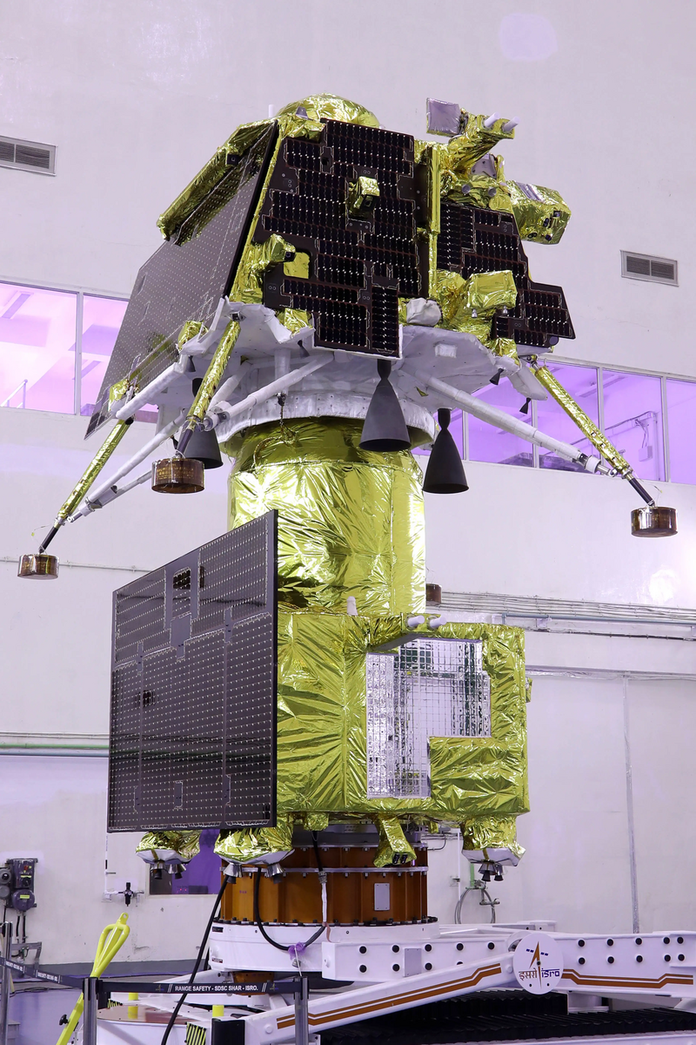Fig 1: Chandrayaan-3 Integrated Module
Chandrayaan-3 was launched from Satish Dhawan Space Centre on 14 July 2023. The spacecraft entered lunar orbit on 5 August, and the lander touched down near the Lunar south pole on 23 August at 18:03 IST (12:33 UTC), making India the fourth country to successfully land on the Moon, and the first to do so near the lunar south pole. On 3 September the lander hopped and repositioned itself 30–40 cm (12–16 in) from its landing site.
The Vikram lander and Pragyan rover were set to sleep on 2 and 4 September respectively due to depleting solar power with sunset at the landing site. The lander and rover were scheduled to start working again at local sunrise on 22 September.However on 22 September, Vikram Lander and Pragyan rover missed Wake-up call.
Background
On 22 July 2019, ISRO launched Chandrayaan-2 on board a Launch Vehicle Mark-3 (LVM3) launch vehicle consisting of an orbiter, a lander and a rover.The lander was scheduled to touch down on the lunar surface on 6 September 2019 to deploy the Pragyan rover. The lander lost contact with mission control, deviated from its intended trajectory while attempting to land near the lunar south pole, and crashed.
The lunar south pole region holds particular interest for scientific exploration. Studies show large amounts of ice there. Mountainous terrain and unpredictable lighting protect the ice from melting, but they also make landing scientific probes there a challenging undertaking. The ice could contain solid-state compounds that would normally melt under warmer conditions elsewhere on the Moon—compounds which could provide insight into lunar, Earth, and Solar System history. For future crewed missions and outposts, ice could also be a source of drinking water and of hydrogen for fuel and oxygen.
The European Space Tracking network (ESTRACK), operated by the European Space Agency (ESA), and Deep Space Network operated by Jet Propulsion Laboratory (JPL) of NASA are supporting the mission. Under a new cross-support arrangement, ESA tracking support could be provided for upcoming ISRO missions such as those of India's first human spaceflight programme, Gaganyaan, and the Aditya-L1 solar research mission. In return, future ESA missions will receive similar support from ISRO's own tracking stations.
Objectives
ISRO's mission objectives for the Chandrayaan-3 mission are:

- Engineering and implementing a lander to land safely and softly on the surface of the Moon.
- Observing and demonstrating the rover's driving capabilities on the Moon.
- Conducting and observing experiments on the materials available on the lunar surface to better understand the composition of the Moon.
Launch
Chandrayaan-3 was launched aboard an LVM3-M4 rocket on 14 July 2023, at 09:05 UTC from Satish Dhawan Space Centre Second Launch Pad in Sriharikota, Andhra Pradesh, India, entering an Earth parking orbit with a perigee of 170 km (106 mi) and an apogee of 36,500 km (22,680 mi).
Orbit
After a series of Earth bound manoeuvres that placed Chandrayaan-3 in a trans-lunar injection orbit,[37][38][39] ISRO performed a lunar-orbit insertion (LOI) on 5 August, successfully placing the Chandrayaan-3 spacecraft into an orbit around the Moon. The LOI operation was carried out from the ISRO Telemetry, Tracking, and Command Network (ISTRAC) in Bengaluru.
On 17 August, the Vikram lander separated from the propulsion module to begin the last phase of the mission.
Landing
On 23 August 2023, as the lander approached the low point of its orbit, its four engines fired as a braking manoeuvre at 30 kilometres (19 mi) above the Moon's surface. After 11.5 minutes, the lander was 7.2 km (4.5 miles) above the surface; it maintained this altitude for about 10 seconds, then stabilized itself using eight smaller thrusters and rotated from a horizontal to a vertical position while continuing its descent.
It then used two of its four engines to slow its descent to roughly 150 metres (490 ft); it hovered there for about 30 seconds and located an optimal landing spot before continuing downward and touching down at 12:33 UTC.
Surface operations
On 3 September, the rover was put into sleep mode after it had completed all of its assignments. Its batteries were charged and receiver left on, according to ISRO, in preparation for the impending lunar night."The rover's payloads are turned off and the data it collected has been transmitted to Earth via the lander", the statement said. Chandrayaan-3's lander and rover were expected to operate only for one lunar daylight period, or 14 Earth days, and the on-board electronics were not designed to withstand the −120 °C (−184 °F) nighttime temperatures on the Moon. If the rover and lander were to survive the lunar night, the mission is planned to be extended for further science operations.
Vikram fired its engines for a brief 'hop' on the lunar surface on 3 September, ascending 40 cm (16 in) off the lunar surface and translating a similar distance laterally across the surface. The test demonstrated capabilities to be used in potential future sample return missions. The instruments and rover deployment ramp were retracted for the hop and redeployed afterwards.
Mission life
Propulsion module: Carries lander and rover to 100-by-100-kilometre (62 mi × 62 mi) orbit, with operation of experimental payload for up to six months.
- Lander module: one lunar daylight period (14 Earth days).
- Rover module: one lunar daylight period (14 Earth days).
Team
- ISRO chairman: S. Somanath
- Mission Director: S. Mohanakumar
- Associate Mission Director: G. Narayanan
- Project Director: P. Veeramuthuvel
- Associate Project Director: Kalpana Kalahasti
- Vehicle Director: Biju C. Thomas
Funding
In December 2019, ISRO requested the initial funding of the project, amounting to ₹75 crore (US$9.4 million), out of which ₹600 million (US$7.5 million) would be for meeting expenditure towards machinery, equipment, and other capital expenditure, while the remaining ₹150 million (US$1.9 million) was sought for operating expenditure. Amit Sharma, CEO of an ISRO vendor, said, "With local sourcing of equipment and design elements, we are able to reduce the price considerably."
Confirming the existence of the project, ISRO's former chairman K. Sivan stated that the estimated cost would be around ₹615 crore (equivalent to ₹721 crore or US$90 million in 2023).
Results
The Associated Press, while commenting on the success of the mission, said, "The successful mission showcases India's rising standing as a technology and space powerhouse and dovetails with Prime Minister Narendra Modi's desire to project an image of an ascendant country asserting its place among the global elite.
Domestic reactions
- Chandrayaan-3's landing live stream on ISRO's official YouTube channel received eight million concurrent viewers, which is the highest in YouTube's history.
- Congratulating the ISRO team behind the successful Chandrayaan-3 mission at ISRO Telemetry, Tracking and Command Network in Bengaluru, Prime Minister Narendra Modi announced that the touchdown point of the Vikram lander would henceforth be known as Shiv Shakti point. He further declared 23 August, the day the Vikram lander landed on the Moon, as National Space Day.
- ISRO chief S. Somanath exclaimed "India is on the Moon" after the successful touchdown."We learnt a lot from our failure and corrected it. It's now 14 days of work and we have to conduct experiments," he told India Today.
- P Veeramuthuvel, the Project Director of the mission said, "It's a great moment of happiness. On behalf of the team it gives me immense satisfaction on achieving this goal as the Project Director of the mission. The entire mission operations right from launch till landing happened flawlessly as per the timeline". S. Mohana Kumar, the Mission Director, said that Chandrayaan-3 was a "team effort".
- Meanwhile, former ISRO chief K Sivan, under whose tenure the Chandrayaan-2 was launched said, "We are really excited to see this grand success. For this, we have been waiting for the last four years. This success is sweet news for us and for the entire nation."
- DY Chandrachud, the Chief Justice of India hailed the landing as "a milestone in the onward march of our nation" and congratulated the ISRO team.

References
- https://en.wikipedia.org/wiki/Chandrayaan-3

